Atitit 合并sql批量压缩模式

目录

Ori single thrd 2

1781/30s ori+rds local 5

3000/30s mltqure +batch 5

去除rds+ori 提升30% 2360 /30s 5

Rds1013+ori 1676/30s 6

Nords +mltqry 2170、30s 6

Nords+mltqry batch 3000 ，30s 7

Mlt hrd.. 12k/min 7

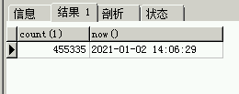

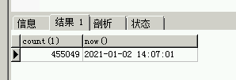

300、30s

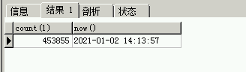

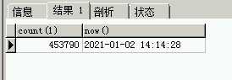

55 30s

Ori

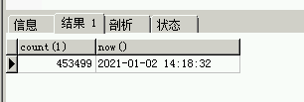

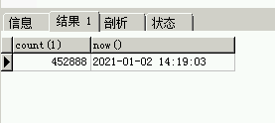

611/30s 1200/min

## Ori single thrd

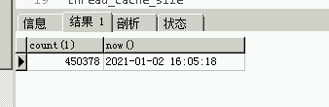

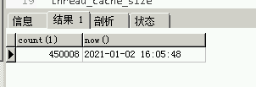

370/30s

Now sqlMltqry and batch/per3sec

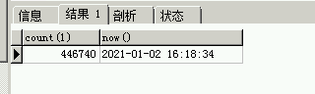

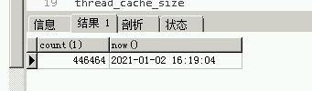

300/30s

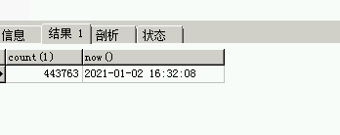

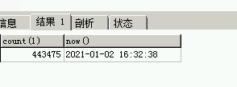

400/30s

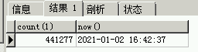

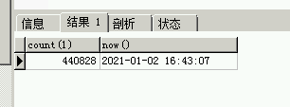

450/30s

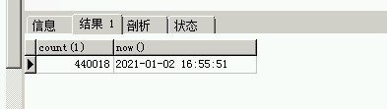

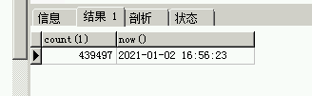

521/30s

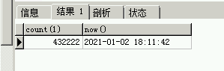

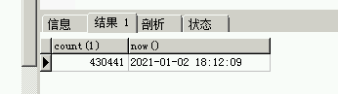

## 1781/30s ori+rds local

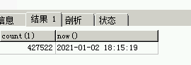

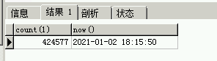

## 3000/30s mltqure +batch

## 去除rds+ori 提升30% 2360 /30s

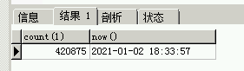

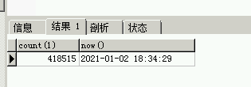

## Rds1013+ori 1676/30s

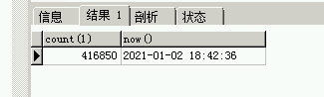



## Nords +mltqry 2170、30s

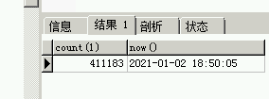

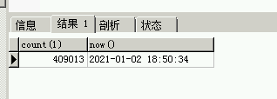

## Nords+mltqry batch 3000 ，30s

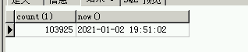

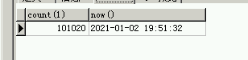

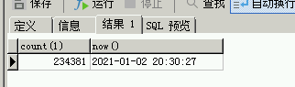

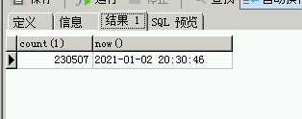

## Mlt hrd.. 12k/min